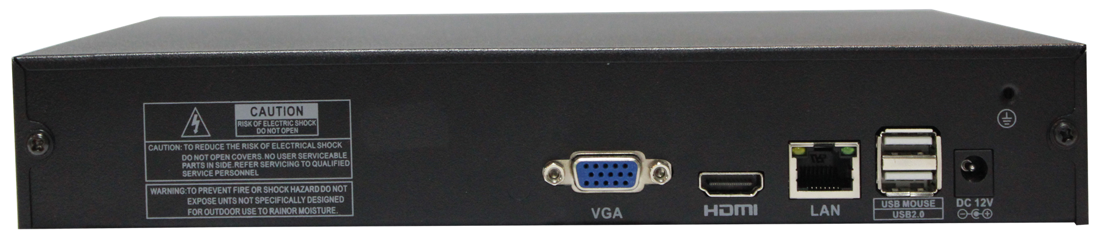
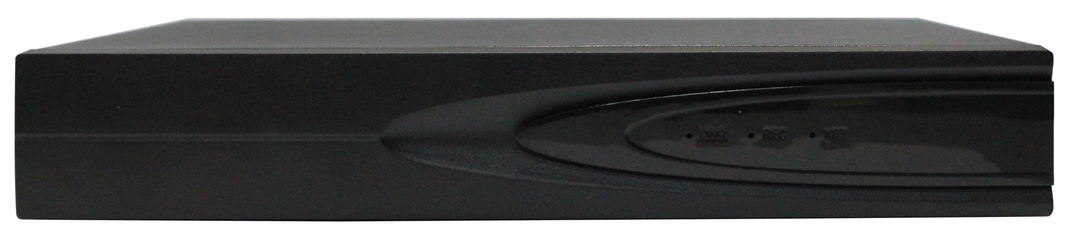
NVR4.0 H.265 Series 9 channels
The most easy-to-use,popular and commercial 9 channel embedded NVR;specially design for store, small warehouse, office and family,access HD IPC,provide preview,recording, forward and so on functions. Support mobile phone monitoring, traversal service,achieve APP seconds connection for preview and remote recording playback, support various network modes:
IPC----NVR---- Seetong Cloud----Seetong Client
IPC-----------------NVR------------Seetong Client
IPC----NVR---- Seetong Cloud----Seetong APP

H.265+, Stable, easy to use, perfect.

Orders | Specification | TS8108D7  1 Disk 9CH H.265+ NVR
1 | System Structure | Embedded LINUX design,pure hardware decode,watchdog,hard disk storage,HDMI HD display,IP network video access.
1 | System Structure | Main processor Hi3536D;
2 | Video Input | HD IPC access, each channel support dual stream access, support auto search,add,recording,  preview and without debugging;
2 | Video Input | Access bandwidth 64Mbps;
3 | Video Output | 1channel HDMI output,1 channel VGA output,homology with HDMI,support 2560×1440,  1920×1080,1440×900,1366×768,1280×1024,1280×800,1024×768 resolution output show;
3 | Video Output | Support Seetong client preview,APP preview and seconds connection
3 | Video Output | 1/2/4/6/8/9 pictures real time preview;
4 | Video recording resolution | Support 720P/960P/1080P/3MP/4MP/5MP;
5 | Video Capacity | Support H.265+/H.265/H.264 decoding;
5 | Video Capacity | NVR local recording playback support 1CH 5MP or 2CH 2MP; Seetong client recording playback support 2 channels.
6 | Audio | Standard G.711, support audio and video recording,support HDMI output channel preview and playback audio and video, Seetong client audio and video preview and playback;
7 | Storage | 1*SATA hard disk interface,support 8TB capacity;
7 | Storage | Support schedule record, motion detection linkage record, alarm linkage record, cross-border record, regional invasion record;
7 | Storage | Support external USB storage devices (such as ordinary U disk, mobile hard disk) backup;
8 | User | Local maximum support for 38 users;
9 | Network Interface | 1*RJ45 Ethernet interface, support 10/100M self-adaption;support TCP/IP, IPv4, DHCP, NTP, RTSP, P2P, SMTP, GB28181 and so on protocols;
10 | Peripheral Interface | 2*USB2.0 interface(rear); support for the mouse, USB upgrade, import and export;
11 | Front Panel | 1* power,1*record,1*network indicator light;
12 | Business Functions | Support preview/recording/forward/remote service, support alarm linkage, support Seetong client remote control software; support seetong cloud service;
13 | Working Temperature | -10℃～＋55℃
14 | Working Humidity | 10%～90%
15 | Others | DC +12V/2A power input, hots power consumption≤3W (No disk), size 255*210*42mm (W*D*H), weight 608g, support wall hanging;
16 | Optional | audio output optional.

